#include<stdio.h>
#include<conio.h>
void main()
{
int mat[10][10],mat_trans[10][10],row,col,nonZeroValue,i=0,j=0;
printf("\nEnter number of rows and columns: ");
scanf("%d%d",&row,&col);
printf("\nEnter number of non zero elements: ");
scanf("%d",&nonZeroValue);
mat[0][0]=row;
mat[1][0]=col;
mat[2][0]=nonZeroValue;

for(i=1;i<=nonZeroValue;i++)
{
printf("\nFor value %d - ",i);
printf("\n\tEnter Row no., Column No. and Value: ");
scanf("%d %d %d",&mat[0][i],&mat[1][i],&mat[2][i]);
}
printf("\n\t***SPARSE MATRIX IS***");
printf("\n\tNo. of rows No. of columns No. of nonzero values");
printf("\n\t[%d]\t\t[%d]\t\t[%d] ",mat[0][0],mat[1][0],mat[2][0]);
for(i=1;i<=nonZeroValue;i++)
{
printf("\n\t%d\t\t %d\t\t %d ",mat[0][i],mat[1][i],mat[2][i]);
}
mat_trans[0][0]=mat[1][0];
mat_trans[1][0]=mat[0][0];
mat_trans[2][0]=mat[2][0];

for(i=1;i<=nonZeroValue;i++)
{
mat_trans[0][i] = mat[1][i];
mat_trans[1][i] = mat[0][i];
mat_trans[2][i] = mat[2][i];
}
printf("\n\t***TRANSPOSE OF SPARSE MATRIX IS***");
printf("\n\tNo. of rows No. of columns No. of nonzero values");
printf("\n\t[%d]\t\t[%d]\t\t[%d] ",mat_trans[0][0],mat_trans[1][0],mat_trans[2][0]);
for(i=1;i<=nonZeroValue;i++)
{
printf("\n\t%d\t\t %d\t\t %d ",mat_trans[0][i],mat_trans[1][i],mat_trans[2][i]);
}
}

OUTPUT
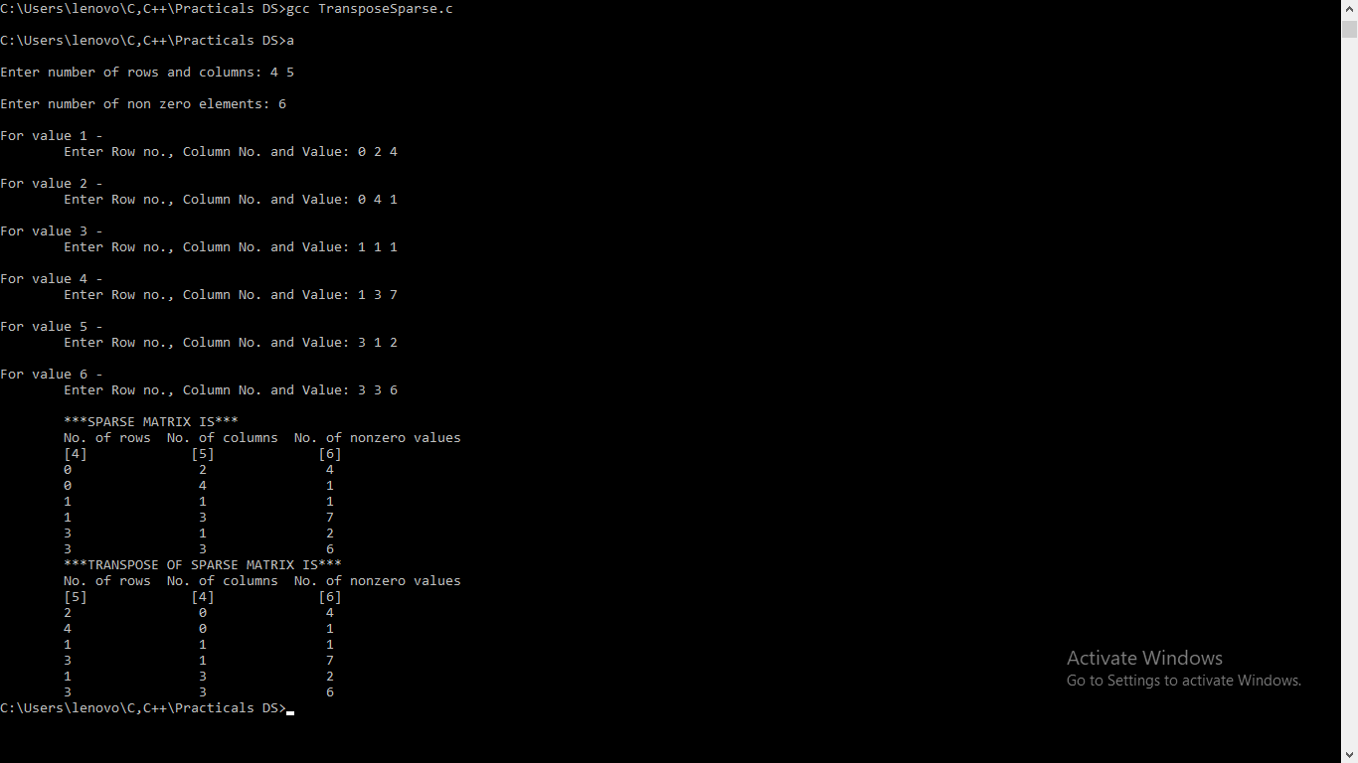

#include<stdio.h>
#include<stdlib.h>
#include<stdbool.h>
#define N 10
int top=-1;
int stack[N];
void push();
int pop();
int peek();
bool isEmpty();
bool isFull();
int main()
{
printf("STATIC ARRAY(Total Capacity: %d)\n",N);
int choice;

while(1)
{
printf("\nChoose any of the following option: \n");
printf("0: Exit 1:Push 2:Pop 3:Peek\n");
printf("4:Check if the stack is empty 5:Check if the stack is full\n\n");
scanf("%d",&choice);
switch(choice)
{
case 0:exit(0);
case 1:push(); break;
case 2:pop(); break;
case 3:peek(); break;
case 4:isEmpty(); break;
case 5:isFull(); break;
default: printf("Please choose correct option!!");
}
}
return 0;
}
void push()
{
if(top==N-1)
printf("Overflow State: can't add more elements into the stack!\n");
else
{
int x;
printf("Enter element to be pushed into the stack:");
scanf("%d",&x);
top=top+1;
stack[top]=x;
}
}
int pop()
{
if(top==-1)
printf("Underflow State: Stack is Empty,can't remove elements from the stack\n");
else
{
int x=stack[top];
printf("Popping %d out of the stack\n",x);
top-=1;
return x;
}
return -1;
}
int peek()
{
int x=stack[top];
printf("%d is the top most element of the stack\n",x);
return x;
}
bool isEmpty()
{
if(top==-1)
{
printf("Stack is Empty:Underflow State\n");
return true;
}
printf("Stack is not Empty\n");
return false;
}
bool isFull()
{
if(top==N-1)
{
printf("Stack is Full:Overflow State\n");
return true;
}
printf("Stack is not Full\n");
return false;
}

OUTPUT
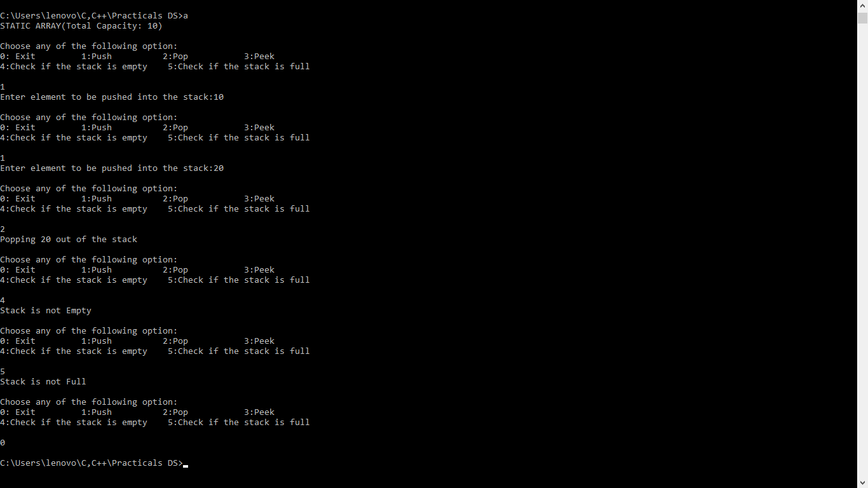

#include <stdio.h>
#include <ctype.h>
#include <stdlib.h>
#define SIZE 20
int pop();
void push(int);
char postfix[SIZE];
int stack[SIZE], top = -1;
void main()
{
int i, a, b, result, pEval;
char ch;
//clrscr();
for(i=0; i<SIZE; i++)
{
stack[i] = -1;
}
printf("\n\tEnter a postfix expression: ");
scanf("%s",postfix);

for(i=0; postfix[i] != '\0'; i++)
{
ch = postfix[i];

if(isdigit(ch))
{
push(ch-'0');
printf("\n\tPushed element is: %d\n",ch-'0');
}
else if(ch == '+' || ch == '-' || ch == '*' || ch == '/')
{
b = pop();
printf("\n\tPoped element is %d\n",b);
a = pop();
printf("\n\tPoped element is %d\n",a);

switch(ch)
{
case '+': result = a+b;
break;
case '-': result = a-b;
break;
case '*': result = a*b;
break;
case '/': result = a/b;
break;
}

push(result);
}
}
pEval = pop();
printf("\n\tThe postfix evaluation is: %d\n",pEval);
//getch();
}
void push(int n)
{
if (top < SIZE -1)
{
stack[++top] = n;
}
else
{
printf("\tStack is full!\n");
exit(-1);
}
}
int pop()
{
int n;
if (top > -1)
{
n = stack[top];
stack[top--] = -1;
return n;
}
else
{
printf("\tStack is empty!\n");
exit(-1);
}
}

OUTPUT
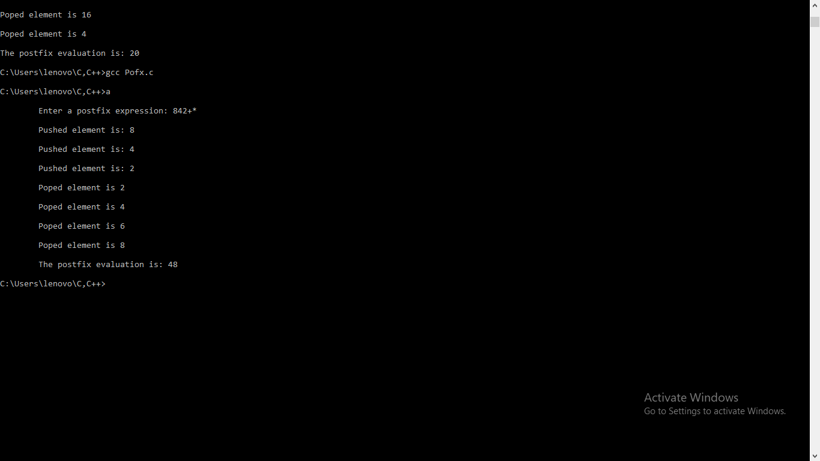

#include<stdio.h>
#include<stdlib.h>
#define n 5
void main()
{
int queue[n],ch=1,front=0,rear=0,i,j=1,x=n;
printf("\tQueue using Array");
printf("\n\t1.Insertion \n\t2.Deletion \n\t3.Display \n\t4.Exit");
while(ch)
{
printf("\n\tEnter the Choice:");
scanf("%d",&ch);
switch(ch)
{
case 1:
if(rear==x)
printf("\n\t Queue is Full");
else
{
printf("\n\t Enter no %d:",j++);
scanf("%d",&queue[rear++]);
}
break;
case 2:
if(front==rear)
{
printf("\n\t Queue is empty");
}
else
{
printf("\n\t Deleted Element is %d",queue[front++]);
x++;
}
break;
case 3:
printf("\t\nQueue Elements are:\n");
if(front==rear)
printf("\t\n Queue is Empty");
else
{
for(i=front; i<rear; i++)
{
printf("\t%d",queue[i]);
printf("\t\n");
}
break;
case 4:
exit(0);
default:
printf("\tWrong Choice: please see the options");
}
}
}
}

OUTPUT
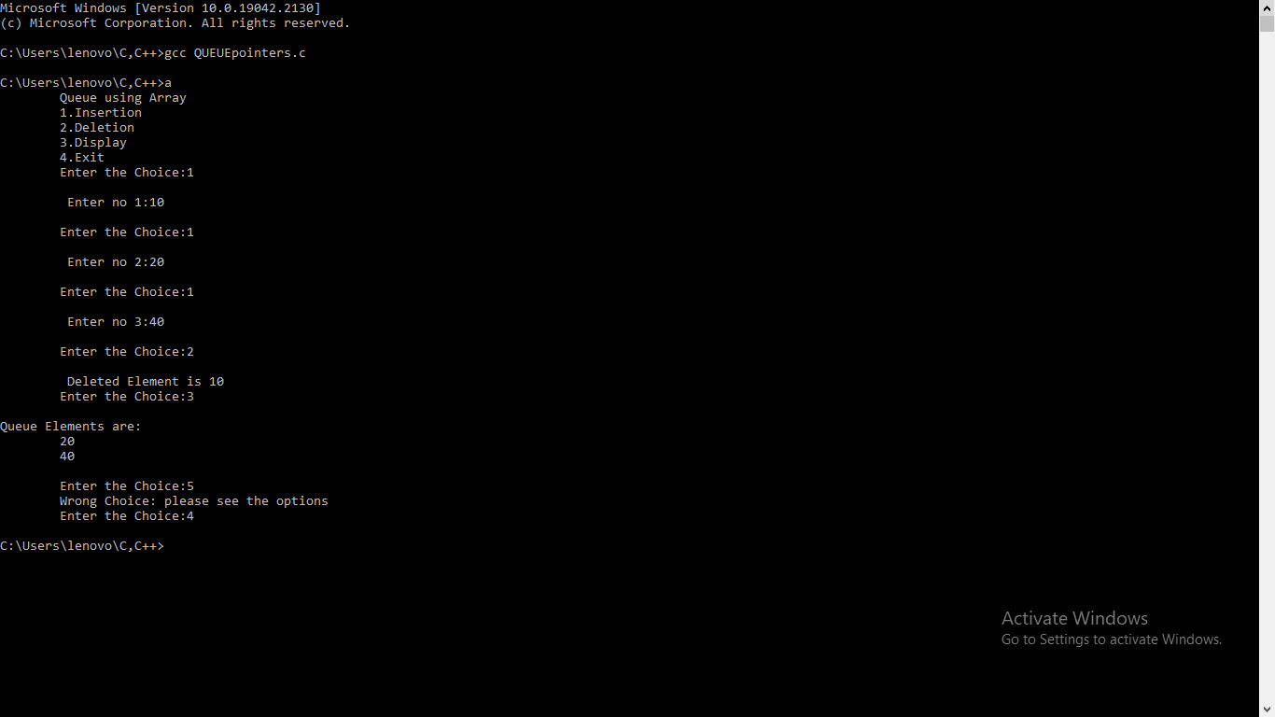

#include<stdio.h>
#include<stdlib.h>
#define n 5
void main()
{
int queue[n][3],ch=1,front=0,rear=0,i,j=1,x=n, r=0;
int f, wt[n];
printf("Queue using Array");
printf("\n1.Insertion \n2.Deletion \n3.Display \n4.Exit");
while(ch)
{
printf("\nEnter the Choice:");
scanf("%d",&ch);
switch(ch)
{
case 1:
if(rear==x)
printf("\n Queue is Full");
else
{
printf("\n Enter process id, Burst time and Arrival time \n");
r=rear++;
scanf("%d %d %d",&queue[r][0], &queue[r][1], &queue[r][2]);
}
break;
case 2:
if(front==rear)
{
printf("\n Queue is empty");
}
else
{
f=front++;
printf("\n Executed process ID is %d\n",queue[f][0]);
x++;
if(f==0)
wt[0]=0;
else
wt[f]=wt[f-1]+queue[f-1][1]-queue[f][2];
printf(" WT= %d", wt[f]);
}
break;
case 3:
printf("\n Queue Elements are:\n");
if(front==rear)
printf("\n Queue is Empty");
else
{
printf(" P_Id\tBT\tAT\n");
for(i=front; i<rear; i++)
{

for(j=0;j<3;j++)
printf(" %d\t",queue[i][j]);
printf("\n");
}
break;
case 4:
exit(0);
default:
printf(" Wrong Choice: please see the options");
}
}
}
}

OUTPUT
